**BSc (Hons) in Computing**

**Level – 6**

[](http://apiit.edu.my/)

**Final Year Project Documentation**

**Module Title: Final Year Project**

**Prepared by:**

**Shifny Ahmed CB007753**

**[HF2161SEENG]**

**Date of Submission: 11th February 2022**

**Instructor: Prof. Priyantha Kumarawadu**

**Word Count: 4747**

**Acknowledgement**

I would like to thank Professor Priyantha for providing all the advice and teaching required to do my FYP and I would like to thank my colleagues for helping me on any mistakes I make regarding my FYP. And finally, I would like to thank Staffordshire University for providing access for most of the online resources required for my research need.

**Table of Contents**

**01.** Introduction 6

01.1. Project Aim, Objective, and Scope 6

**02.** Literature Review 8

02.1. Introduction 8

02.2. Machine Learning and Recommendation Techniques 8

02.3. User Profiling in Recommendation System 11

02.4. Text Vectorization 12

02.5. Similarity Measuring 13

02.6. Conclusion 14

**03.** Requirement Analysis 15

03.1. User Requirements 15

03.2. System Functionalities 15

03.3. Functional Requirements 15

03.4. Non-Functional Requirements 16

**04.** Methodology 17

04.1. Research and Application of Methods 17

04.2. Technology Selection 17

04.3. Development Platform 17

**05.** Solution Concept 18

**06.** System Design 20

06.1. High-level use case 20

06.2. Entity Relationship Diagram 21

06.3. Use Case Scenarios 22

06.4. Activity Diagram 29

06.5. Sequence Diagram 33

**07.** Implementation 40

07.1. Recommendation Engine 40

07.2. Web Application 45

07.3. Recommendation function 46

**08.** Testing 52

08.1. Research on Test Plan 52

08.2. Test Plan 54

09. Critical Evaluation 58

10. Conclusion 59

11. Reference 60

12. Appendix 62

12.1. Project Planning 62

**Table of figures**

Figure 1: TF-IDF-Formulae 12

Figure 2: Cosine Similarity - Angle Definition 13

Figure 3: High Level Component Diagram 19

Figure 4: High-Level Use Case 20

Figure 5: ER Diagram 21

Figure 6: Activity diagram - Register 29

Figure 7:Activity Diagram - Login 30

Figure 8:Activity Diagram - Recommend based on user interest 30

Figure 9:Activity Diagram - Add Review 31

Figure 10: Activity Diagram - UPDATE PLUMBER AS ARRIVED 31

Figure 11: Activity Diagram - UPDATE PLUMBER AS WORK COMPLETED 32

Figure 12: Activity Diagram - EDIT PROFILE 32

Figure 13: Sequence Diagram - Register 33

Figure 14: Sequence Diagram - Login 34

Figure 15: Sequence Diagram - Recommend Service Provider Based on user interest 35

Figure 16: Sequence Diagram - Add review 36

Figure 17: Sequence Diagram - Update Plumber as arrived 37

Figure 18: Sequence Diagram - Update plumber as work completed 38

Figure 19: Sequence Diagram - Edit Profile 39

Figure 20: Recommendation based on selected plumber's work 46

Figure 21: Output of "recommendation based on selected plumber’s work" 47

Figure 22: Recommendation based on city where user lives 48

Figure 23: Output of "recommendation based on city where user lives" 49

Figure 24: Recommendation based on the user interest 50

Figure 25: Output of "recommendation based on the user interest" 51

# Introduction

In this modern world, people often get used to being served at their desired place, which is mostly at home. These people expect service providers such as doctors, nurses, barbers, plumbers, electricians, carpenters, car washers, cleaners, etc. to visit their home and offer their services, and most of those people have already been hiring these types of service providers to come to their home. This hiring is being done in a manual way by asking for suggestions of well-known service providers to people for the work they want done, and not every individual service provider in the above-mentioned category will be available all the time and the manual process of hiring will cost more time and effort.

In order to automate this process, we will be building a system that will allow people to register through the application as customers and hire their desired service provider for the service they require. This system will also recommend service providers to the customer based on the city customer lives and based on the work of any selected service provider, the first release of the system will be on website which will have several functionalities for the customers in a user-friendly manner.

## Project Aim, Objective, and Scope

The main goal of this project is to connect customers with local professional service providers. This can be done by creating a recommendation system that will recommend the best service providers in their city as well as service providers based on their preferences.

We will implement a web application that will allow customers all over Sri Lanka to register and hire the best service provider in their city. Service providers in each category will be recommended to the customer based on the city and the customer's interests. The project's final product will be the first version of a web application that allows customers to register and hire only plumbers in their city, and several plumbers will be recommended based on their selection.

In order to start the project few areas have to be researched to understand the basics such as:

* **User Profiling** - Analyzing the characteristics of users’ interest is a crucial part in developing a recommendation system for home services*.*
* **Recommendation system using machine learning -** As machine learning has shown great success in predicting information based on the past information provided, this can be used to recommend a service provider to the customer based on service provider rating.
* **Collaborative Filtering** - This is a filtering strategy used to recommend a user’s preference to another similar user.
* **Content-Based Filtering** - This is the normal strategy used in most of the recommendation system which recommends the user based on the past interaction and preference of the user.
* **Python and Machine Learning** - Python is among the first programming languages to gain machine learning support in the form of libraries and tools. This can be researched for further details to learn the language.
* **Similar Web based Service providing System** - This can be researched to learn what functionalities are most popular among them and how much time they take to get implemented.

After the research and efficient information has been collected, we will be moving onto the implementation where we will be applying the dos and don’ts which we had identified. Dos and don’ts are listed below:

* The payment gate way won’t be implemented in the first version of this application.
* The system builder will need to implement the application in a way where only plumber needs to be available in the service providing section in the first version of the application.
* The system builder will need to implement the application in a way where customer will be able to see the information such as name, work, city, occupation, qualification, availability, and customer reviews of the service provider.
* The system will not have any implementation where the customer can call the hired service provider through application.
* The system will not have any implementation where the customer can track the live location of the hired service provider.
* This system will only allow have customer’s functionalities in the first version of this application.

# Literature Review

## Introduction

People in today's environment are accustomed to being served at their preferred location, which is usually their house. These people expect service providers such as doctors, nurses, barbers, plumbers, electricians, carpenters, car washers, cleaners, and other professionals to come to their homes and offer their services, and the majority of them have already done so. This hiring is done manually by asking known people for service providers to be suggested for the work they need done, and not every service provider in the above-mentioned category will be available at all times. In this instance, the customer may have to wait for their turn to be served. To solve this, we came up with a system which is built using machine learning to offer a Service Provider Recommendation System which will list down the available service providers and will recommend the best suiting service providers according to each user’s interest.

To improve the efficiency of this home service recommendation system, it is critical to manage data generated on a daily basis in the home service application correctly, and to do so, systems must execute data collection, processing, analysis, and distribution(Garcia, et al., 2020)**.** Proper data management can boost productivity by allowing you to hire more service providers and earn more trust in the system. Over the year the amount of data generated by global sources of data such as Web sites, social media, smartphone apps, news networks, weather, political institutes, society, and the economy has been steadily increasing. Without appropriate preparation and processing, no matter how large the data is, it may be useless(Ribeiro, et al., 2015). In the home service application, best service providers over the years can be recommended to all the customers whenever the application is accessed, by collecting various customer rating on each service provider to arrange each service provider by ascending order in terms of overall rating and recommend them to the customer or the service providers may be recommended based on individual customer preference which will be collected based on the customer’s past activity. To make such recommendation, Machine learning is often used.

## Machine Learning and Recommendation Techniques

Machine Learning is a set of statistical methods for creating mathematical models that can draw conclusions from data samples (known as a training set) (Ribeiro, et al., 2015). It is among the most rapidly developing areas of computer science (Alpaydin, 2020). For scientific modeling, consumer behavior, energy consumption predictions, related article recommendation, and user trends, a variety of machine learning algorithms have been applied to extract useful knowledge from data(Ribeiro, et al., 2015).

There are many machine learning algorithms such as Association Rules, Unsupervised learning, Supervised Learning, and Reinforcement learning. Association rules is often used in supermarket basket analysis, this is the process of defining associations between things purchased by customers. For example: Consumers who buy milk are likely to buy Choco powder as well, and buyers who buy milk, but not Choco powder are potential Choco powder customers(Alpaydin, 2020). Unsupervised learning is a basic idea in which we don't have a supervisor to offer accurate values and only have input data to detect regularities in(Alpaydin, 2020), this is mostly used for unlabeled datasets. Supervised learning is vice versa explanation of unsupervised learning, we will be doing the machine learning with datasets which are labeled, few examples of the algorithms used are: Classification, Linear Regression, Naïve bayes and etc. Reinforcement learning is where the output of the system will be sequence of action which will be used to predict the future actions. One place where this can be used is gaming. Chess, for example, has a modest number of rules but is extremely complex due to the enormous number of possible moves at each phase and the overall number of moves throughout the game and good algorithm can be used which can learn to play games well by learning all the possible sequence of action(Alpaydin, 2020).

Techniques Used to build a recommendation system are many, 3 of those will be discussed below:

* + 1. **Content based Filtering**

Based on the user's prior activities or input, content-based filtering recommends things that are similar to what they like. Some user-related characteristics may be offered expressly by the user. Other aspects, such as the programs they've already installed, may be implied.

This is one of the most effective recommendation techniques for new projects with little or no user data.

* **Implementation Process**

There are two methods that may be applied in this situation. To begin, customers can be provided a list of attributes from which they can select the ones that they most identify with. Second, the algorithm may remember which goods the user has previously selected and add those characteristics to the user's data (Shoval, et al., 2008).

* **Advantage**

Due to the little quantity of data, this approach is easily scalable. Furthermore, as it’s not required to compare data with other users, unlike other models, it may provide specialized findings tailored to the present user (Shoval, et al., 2008).

* **Disadvantage**

This model demands a significant level of domain expertise on the part of those tasked with attributing features to products. As a result, its accuracy is highly dependent on the accuracy of that knowledge. Furthermore, content-based filtering is heavily reliant on previously identified user preferences. As a result, it is restricted in that it cannot expand on previously identified user interests (Shoval, et al., 2008).

* + 1. **Collaborative Filtering**

Collaborative filtering is a method to extract items that a user might like based on the actions of other users. It works by scanning through a huge group of users to discover a smaller group of users with similar preferences to a specific user. It analyzes their favorite products and creates a ranked list of recommendations(Ekstrand, et al., 2010)**.**

* **Implementation Process**

The initial step is to look for users or objects that are comparable. The second phase is to forecast user ratings for things that have not yet been rated.

* + 1. **Demographic Filtering**

Users are classified into demographic groups based on their personal characteristics. The input data for the recommendation process comes from these classes. The goal of this technique is to identify groups of people who enjoy a particular product rather than a single brand or service(Ryngksai & Chameikho, 2014).

* **Implementation Process**

If people in class B enjoy product A and there is a person b in class B who has not yet seen product A, this product can be recommended to person b(Ryngksai & Chameikho, 2014).

Any recommendation system's main idea is to recommend items to the potential customer by predicting their utility based on previous user actions or similar user actions. It's possible that the user profile will be utilized to filter the user's preferred content. Basically, Content-Based-Filtering predicts and recommends contents, including unseen ones, to new incoming users based on the preferences of the current user. These items may be comparable to previous rated items or contain keywords that are similar(Paireekreng, 2013). In the Collaborative Filtering technique, on the other hand, the preferences of other users must be considered for the user who is now using the recommendation system (Xu, et al., 2010). Similar users can be identified in collaborative filtering using their frequent preferences and in future, preference of one user can be recommended to other similar users. But Meteren and Someren suggested to construct a recommendation system based on content-based-filtering and collaborative filtering jointly to make the system more effective. They also discovered that the precision ratios for prediction for different topics in the same document could differ(Meteren & Someren, 2000).

## User Profiling in Recommendation System

User profile is an important part of the recommendation system since it allows users to get personalized content and be recommended items that are relevant to them (Paireekreng, 2013). Wagner was the first to develop the concept of a user profile (Wagner, et al., 2002). The study proposed a framework for sophisticated mobile service personalization based on a profiling strategy that makes use of the semantic enrichment service. User modeling can assist in the creation of a user profile based on demographic factors in order to determine a user's characteristics. This can give a group of people with content that is relevant for their requirements(Paireekreng, 2013). The early-stage difficulty in the recommendation system can be addressed by the user profile, which tackles the issue of a user's lack of information.

## Text Vectorization

Text Vectorization is a process that involves converting text into numerical form. There are several ways to perform text vectorization.

* + 1. **TF-IDF**

The TF-IDF algorithm compares the relative frequency of words in a single document to the inverse proportion of that word across the entire document corpus. This determines the importance of a provided word in a given document (Salton & Buckley, 1988).

The TF-IDF is calculated as follows: Given a document collection *D*, a word *w*, and a single document *d є D*, we calculate the TF-IDF values.

Figure 1: TF-IDF-Formulae

where *f* *w, d* is the number of times w appears in *d*, |*D*| is the corpus size, and *f**w*, *D* is the number of documents where w appears in *D* (Salton & Buckley, 1988).

* + 1. **Count Vectorizer**

The scikit-learn Python library provides Count Vectorizer. It is used to convert a text into a vector based on the frequency of each word that appears throughout the text. The performance of Count Vectorizer increases when used on short words which is mostly the case in our project (Geeksforgeeks, 2020).

We're looking for similarities between service providers based on the "work" and "city" columns, which contain sentences of no more than 2-4 words. The TF-IDF algorithm tends to downplay the significance of words that are more common throughout the corpus. Because our work and city columns have a limited number of words, each word is equally important. As a result, using the "Count Vectorizer" for this project would be appropriate.

## Similarity Measuring

We may need to determine how similar a product is to one that the customer likes or is interested in before we can recommend it to them. This is where similarity metrics come into play. Anything can be used to determine how similar two products are. For example: the color, taste, or size of a fruit, can be used to determine its similarity.

In machine learning, similarity scores range from 0 to 1, with 1 indicating the most similar product (100 percent similar) and 0 indicating the least similar product (0 percent similar).

* + 1. **Cosine Similarity**

Cosine similarity is a metric for determining how similar products are regardless of size. It calculates the cosine of the angle formed by two vectors projected in three dimensions. This is also one of the most widely used approaches in machine learning for determining similarity. (Ye, 2011).

Figure 2: Cosine Similarity - Angle Definition

The cosine similarity measure is illustrated in the diagram above, where the similarity value is 0 when the angle between two vectors is 90 degrees; this indicates that the two vectors are unrelated. The similarity measure gets closer to 1 as the angle between the two vectors gets closer to each other; this means that both vectors are more similar to each other (Ye, 2011).

## Conclusion

As machine learning has been found to be the only approach to building a recommendation system, different machine learning algorithms and filtering techniques have been found.

In this review, a home service recommendation system was proposed with all the relevant information required to implement and test it. The problem of the home service recommendation system in the early stages of recommendation can be considered based on content-based-filtering. And when the time processes, both collaborative and content-based filtering can be used jointly to make the system more effective, as suggested by Meteren and Someren (Meteren & Someren, 2000).

Content-based filtering can be accomplished in the first version by carrying out a few steps of the machine learning approach to any recommendation system. The training dataset needs to be preprocessed to remove any non-ASCII words and stop words, convert the words into lower case and attach them to the dataset as a new column. The words in the cleaned column can be converted into a vector based on the frequency of each word that appears throughout the column using the Count Vectorizer. Finally, to measure the similarity between the words, cosine similarity, which is one of the most widely used similarity measures in machine learning, can be used to find the similarity scores of each word in the column to each other. And to recommend any service provider to the customer, we can implement a function that takes into account the factor on which the recommendation needs to be made and recommend similar service providers to the customers.

The recommendation system can also utilize the benefit of user profiling, which can provide the user with personalized content and recommend relevant items to them. There is indeed a shift away from recommendations based on other users' ratings and toward personalized recommendations based on user preferences when the user shares more information related to the home services. Users can also manage their own preferences and profiles in order to receive customized content based on their user profile and how they manage their content choices.

# Requirement Analysis

## User Requirements

* **Customers**: These are public who will be able to register through our application to hire home service providers whenever required after the subscription has been made.

## System Functionalities

* The system should be able to keep track of all the services hired by the customer in a database with all the relevant data including id of hired service provider and the customer.
* The system must be able to keep track of current hiring and hiring history of the logged in user.
* System must be able to provide recommendation based on the city user lives.
* System must be able to provide recommendation based on most frequently hired service in the user’s hiring history.
* System must recommend plumbers based on the work of any plumber the user selects.
* System must be able to send notification on important information of the user.
* System must be able to display the logged in user’s task bar after the user logs in.

## Functional Requirements

Functional requirement is a software requirement which describes a functionality that a software component or system must be capable of accomplishing(Chung, et al., 2000). This section will be addressing all the functions that the system can perform.

* User must be able to register themselves in the application.
* A user authorization method must be included in the system, in which users must identify themselves using a username and password. Only users with this level of authorization have access to the system's data.
* The user must be able to log out of the application whenever wanted.
* User must be able to view their profile details
* User must be able to edit their profile details.
* User must be able to view currently hired plumber
* User must be able to view currently hired plumber details
* User must be able to update currently hired plumber as arrived
* User must be able to update hiring as work completed
* User must be able to view hired history of user
* User must be able to view details of individual hired history of user
* User must be able to add review on each hiring
* User must be able to view their review on each hiring
* User must be able to view all the customer review on all plumbers
* User should be able to hire a service provider by clicking the “Hire Now” button.

## Non-Functional Requirements

In software system engineering, non-functional requirements are software requirements that specify how the software will accomplish something rather than explaining what it will do(Chung, et al., 2000).

* **Performance**
* The application will need to load the login page to the user within 3-5 sec of opening
* The application will need to load the home page to the user within 1-3 sec of logging in
* Each request made should be processed within 2-4 seconds.
* **Usability**
* Customer must be able to view the general details of the service providers.
* The Application UI needs to be engaging.
* The system home page needs to be manipulative to attract new customers
* Functionalities of the user must be handled and processed in a user-friendly manner.
* **Security**
* User password must be encrypted using strong hashing.
* Logged out user must not be able to make use of logged in user’s functionality before logging in again

# Methodology

## Research and Application of Methods

As our system is about recommending a service provider to the customers, this application can be named as a recommendation system which basically is built using machine learning algorithms.

Here, we have decided to use a manually made plumber dataset which consist details of various Sri Lankan plumbers. We have decided to apply content-based filtering technique to overcome the starter problem.

## Technology Selection

* Python and flask will be used to build this Home Service Recommender System using machine learning algorithms such as content-based filtering.
* As this is a web development project, no mobile development frameworks or libraries will be used.
* Content based Filtering will be used in this system to recommend service providers to the customers.

## Development Platform

The final outcome of this project will be on a web application, so a development language, framework, and IDE will be needed to develop this application.

**Development Language**

Python is used as the development language as it plays important role in almost all the development such as gaming application, desktop applications, web applications, mobile applications and etc. It is also considered one of the easiest and high demand development language by most of the software developers.

Version: Python 3.9

For the front end of the application, HTML5 with Bootstrap has been used. To make the front end presentable few CSS and java scripts has also been used. To run python code within html, Jinja2 has been used.

**Framework**

Python is one of the easiest and most powerful development languages, and there are a variety of frameworks available for it.

Django and Flask are the two most popular web frameworks in Python, and we chose Flask as the web framework for this application because it is more understandable and easier to use.

**IDE**

JetBrains' PyCharm is one of the most widely used Python IDEs. PyCharm is the tool that Python developers need to get the job done quickly. PyCharm allows developers to write clean codes.

# Solution Concept

The fundamental idea behind this application is for the system to recommend a service provider to customers depending on their interests. This might be accomplished by enabling the system to have functionalities for user: customers, user can register/login and use the functionalities made accessible to them. The application's solution idea is illustrated in the High-Level Component Diagram below, which shows the system's six primary components: database, customer, service provider, security, service, and recommender. To begin, the customer will require access control, which will be given by the security component. The customer components will rely on the Home Service Database component to complete this procedure. In order for the customer component to look for and engage with the service component, the service component will require the service provider component to provide their service. Finally, the recommender component will handle the fundamental concept of recommending a service provider, and it will rely on the home service database component to give the necessary data. The recommender component will process this data and provide recommendations to the customer component.

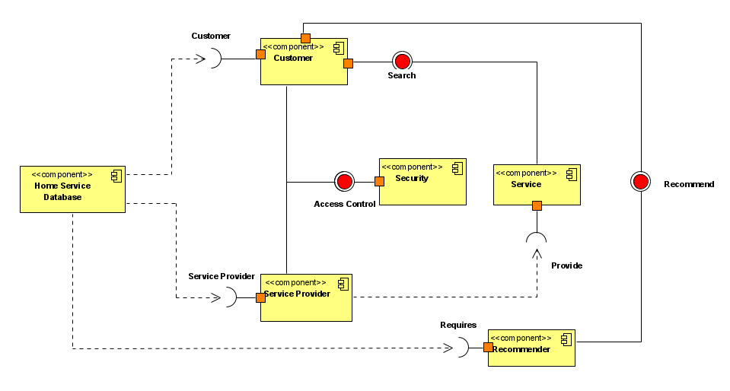

Figure 3: High Level Component Diagram

# System Design

## High-level use case

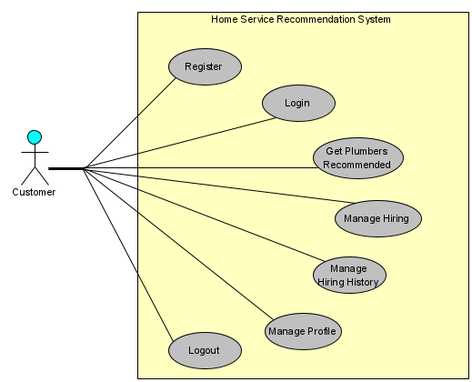

Figure 4: High-Level Use Case

## Entity Relationship Diagram

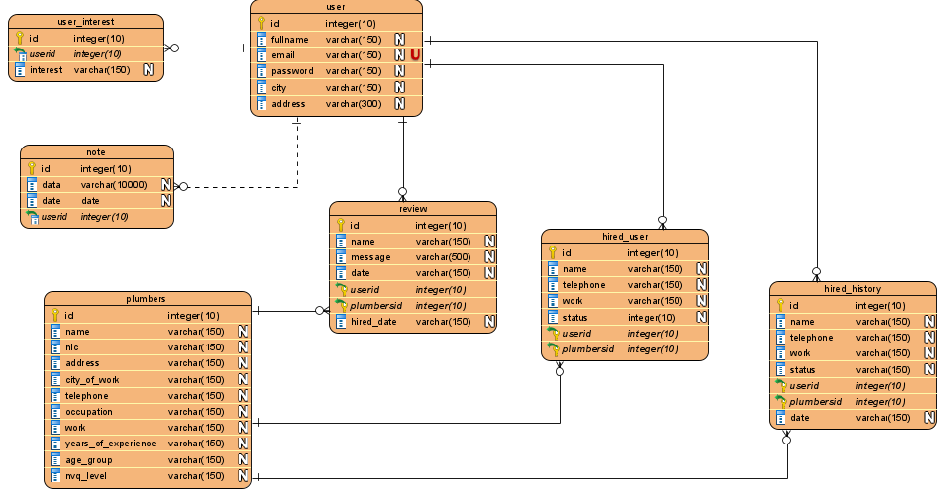

Figure 5: ER Diagram

|  |  |
| --- | --- |
| Use Case Name | Register |
| Description | Allows the user to register into the system |
| Primary Actor | Customer |
| Pre-Conditions | * System should be up and running |
| Basic Flow | 1. System displays the login page 2. User clicks signup 3. System redirects user to their signup page 4. User enters the required information 5. User clicks the “signup” button. 6. System validates the information and saves in database 7. Display success message |
| Extensions | 5A) If any of the required information is empty   1. System prompts the user to fill up the required information.   6A) If the entered password and confirm password does not match   1. The system displays error message   6B) If the entered email already exists  1.System displays an error message  6C) If full name field has value less than 3 character  1.System displays an error message  6D) If address is less than 10 characters  1.System displays an error message |
| Post Condition | The user can login to the system. |
| Optional Information | The password can be in between 7 to 10 characters. |

## Use Case Scenarios

|  |  |
| --- | --- |
| Use Case Name | Login |
| Description | Allows the user to login to the system. |
| Primary Actor | Customer and Service Provider |
| Pre-Conditions | * System must be up and running * User must be registered |
| Basic Flow | 1. System displays the login page  2. User enters the username and password  3. User clicks “Login” button.  4. The system checks whether user exist  5. The system checks whether the entered password matched existing username.  6. System direct the user to their home page. |
| Extensions | 3A) If the Username or Password is Empty   1. System prompts the user to fill the username or password fields   4A) If the user entered username does not exist   1. System display error message   5A) If the user entered password does not match existing username   1. System display error message |
| Post Condition | Hire a plumber |

|  |  |
| --- | --- |
| Use Case Name | Recommend Service Provider Based on user interest |
| Description | Allows the user to get recommendation from the system based on the interest of the currently logged in user. |
| Primary Actor | Customer |
| Pre-Conditions | * System must be up and running * Customer must be logged in |
| Basic Flow | 1. System displays customer homepage  2. Customer clicks “hire”  3.Display Plumber’s page  4. Customer clicks “Recommend based on interest”  5. System checks whether user has any past hiring interest  6. System recommends few plumbers based on the frequently hired plumbering work of the currently logged in user.  7. Display Plumbers page  8. Display recommended plumbers |
| Extensions | 5A) If user has no past hiring interest  1. Display error message |
| Post Condition | Hire plumber |

|  |  |
| --- | --- |
| Use Case Name | Add review |
| Description | Customer can add review about the service customer has hired |
| Primary Actor | Customer |
| Pre-Conditions | * System must be up and running * User must be logged in * User must have hired a plumber * Plumber must have completed his/her work |
| Basic Flow | 1. User clicks the hiring history in navigation bar  2. User clicks “view details” of any plumber  3. System displays the past details of hiring to the user  4. User enters a review  5. User clicks add review  6. System adds the review to the database with customer id, plumber id, review message and date  7. Display success message  8. Display the added review for the selected service. |
| Extensions | 5A) If review is empty  1.Prompt user to fill up the review field |

|  |  |
| --- | --- |
| Use Case Name | Update plumber as arrived |
| Description | This function will be called by the user when he/she clicks “Arrived” button in current hiring page. |
| Primary Actor | Customer |
| Pre-Conditions | * System must be up and running * Customer must be logged in * User must have hired a plumber |
| Basic Flow | 1. User clicks current hiring  2. System displays the currently hired plumber to the user  3. Customer clicks “Arrived”  4. System updates the status of the current hiring as “Arrived’  5. System sends a notification to the user  6. System displays success message |
| Extensions | - |
| Post Condition | Update as work completed |

|  |  |
| --- | --- |
| Use Case Name | Update plumber as Work completed |
| Description | This function will be called by the user when he/she clicks “Work Completed” button in current hiring page. |
| Primary Actor | Customer |
| Pre-Conditions | * System must be up and running * Customer must be logged in * User must have hired a plumber * User must have updated the current hiring as “Arrived” |
| Basic Flow | 1. User clicks current hiring  2. System displays the currently hired plumber to the user  3. Customer clicks “Work Completed”  4. System saves the hiring details with status as “Work Completed” to hired history table.  5. System deletes the current hiring  6. System sends a notification to the user  7. System displays success message  8. System redirects the user to hired history page |
| Extensions | - |
| Post Condition | Add review |

|  |  |
| --- | --- |
| Use Case Name | Edit Profile |
| Description | Allows the user to edit their profile |
| Primary Actor | Customer and Service Provider |
| Pre-Conditions | * System must be up and running * Customer must be logged in |
| Basic Flow | 1. User clicks view profile in navigation bar  2. System redirects the user to profile page  3. User clicks edit profile  4. System redirects the user to edit profile page  5. User makes changes to his/her profile details  6. User clicks “update”  7. System validates updated details  8. System saves the updated information in database  9. Display Profile page  10. Display success message |
| Extensions | 7A) If the entered email already exists and it’s not currently logged in user’s email  1.System displays an error message  7B) If full name field has value less than 3 character  1.System displays an error message  7C) If address is less than 10 characters  1.System displays an error message |
| Post Condition | View profile |

## Activity Diagram

**Register**

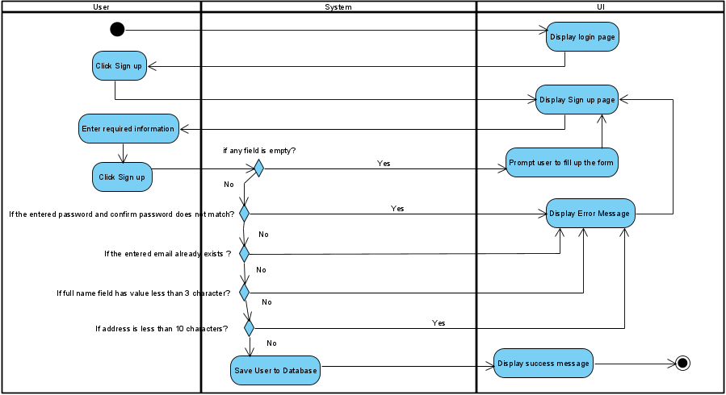

Figure 6: Activity diagram - Register

**Login**

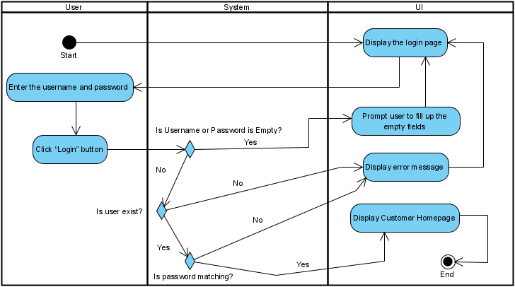

Figure 7:Activity Diagram - Login

**Recommend Service Provider Based on user interest**

Figure 8:Activity Diagram - Recommend based on user interest

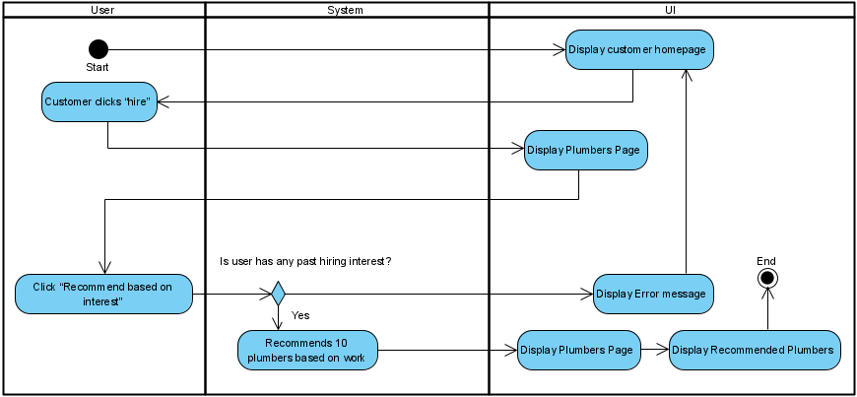

**Add Review**

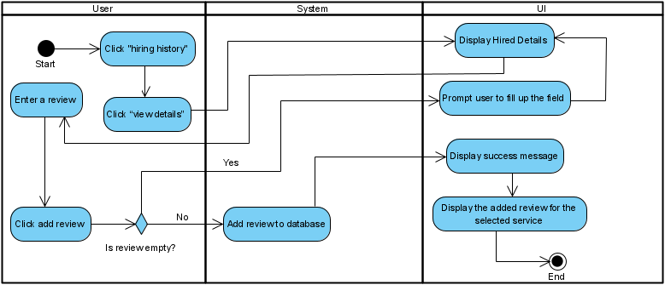

Figure 9:Activity Diagram - Add Review

**Update plumber as arrived**

Figure 10: Activity Diagram - UPDATE PLUMBER AS ARRIVED

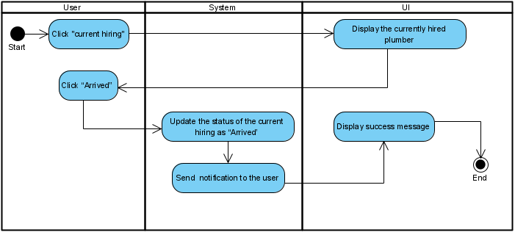

**Update plumber as Work completed**

Figure 11: Activity Diagram - UPDATE PLUMBER AS WORK COMPLETED

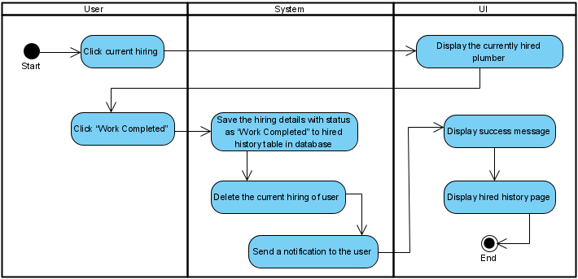

**Edit Profile**

Figure 12: Activity Diagram - EDIT PROFILE

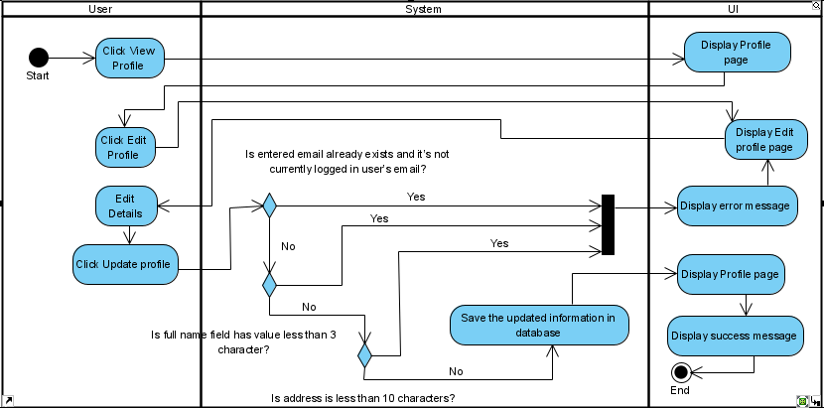

## Sequence Diagram

**Register**

Figure 13: Sequence Diagram - Register

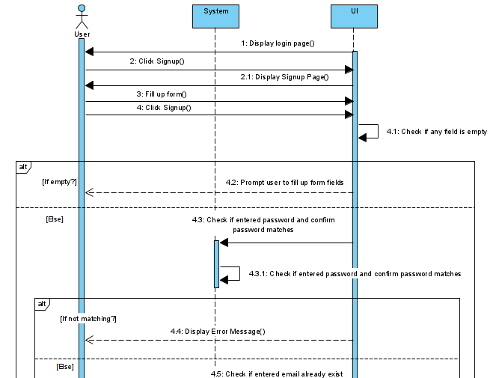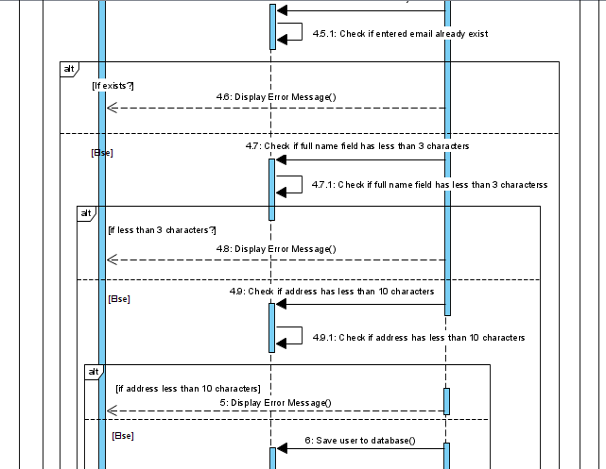

**Login**

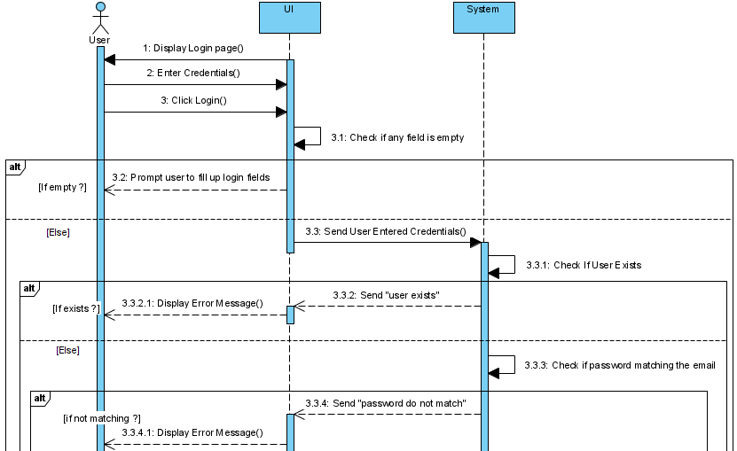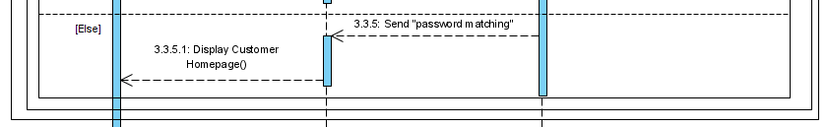

Figure 14: Sequence Diagram - Login

**Recommend Service Provider Based on user interest**

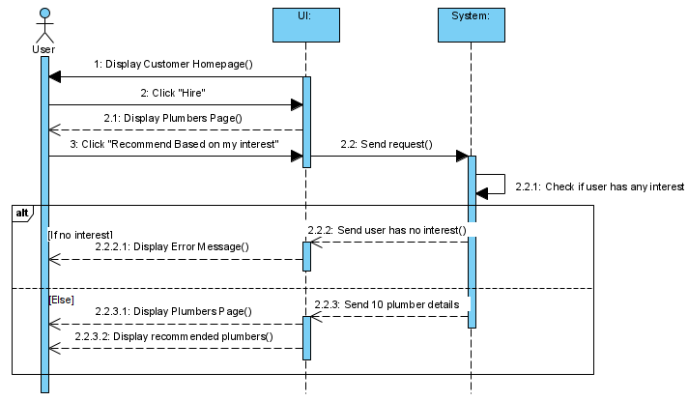

Figure 15: Sequence Diagram - Recommend Service Provider Based on user interest

**Add Review**

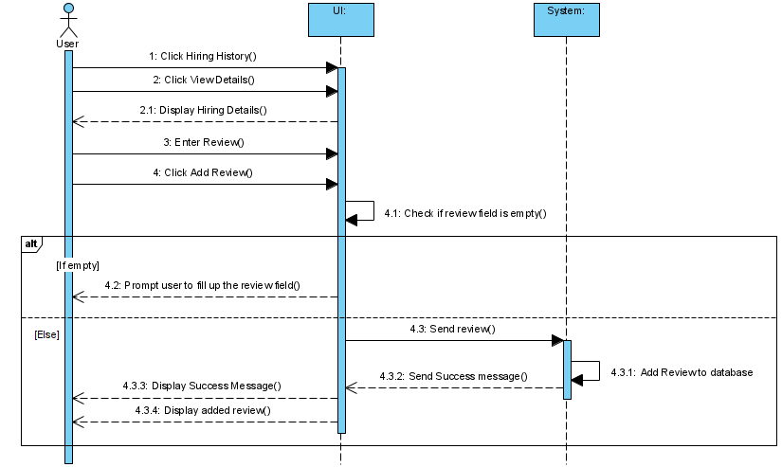

Figure 16: Sequence Diagram - Add review

**Update plumber as arrived**

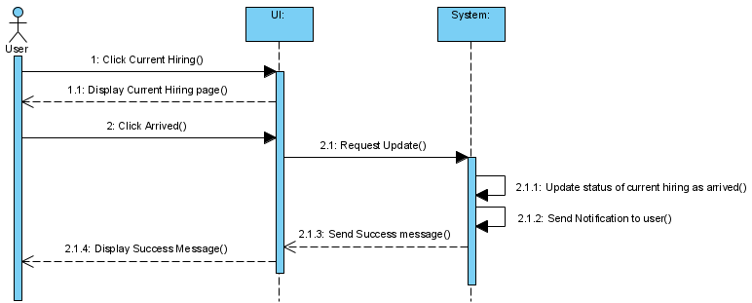

Figure 17: Sequence Diagram - Update Plumber as arrived

**Update plumber as work completed**

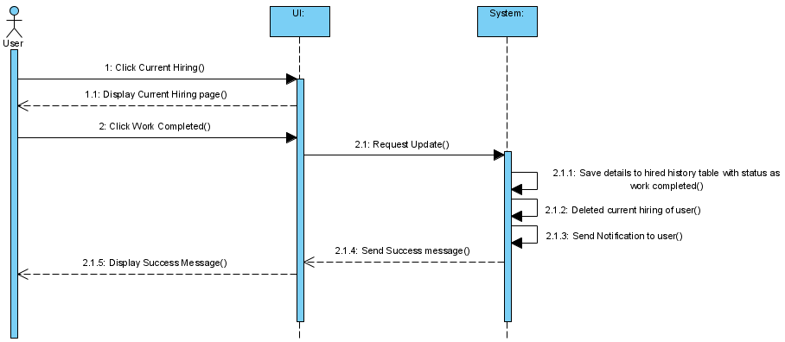

Figure 18: Sequence Diagram - Update plumber as work completed

**Edit Profile**

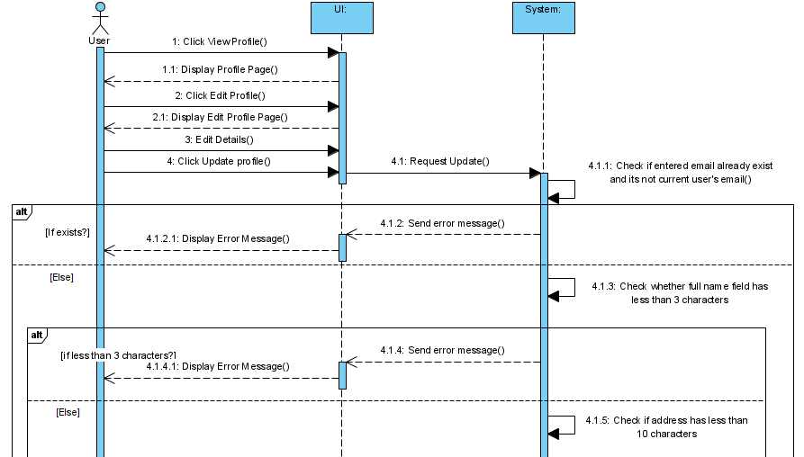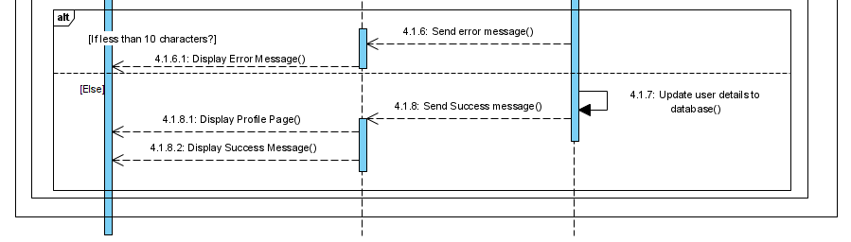

Figure 19: Sequence Diagram - Edit Profile

# Implementation

This Web Application's back end will be based on the Python programming language and the Flask Framework, as mentioned in the Methodology. This web application's front end will be built using HTML5, Booostrap5, CSS, and JavaScript.

## Recommendation Engine

The recommendation engine was developed and tested using Jupyter notebook. Below is the recommendation engine developed and tested in Jupyter notebook for recommending plumbers based on work.

Loading dataset

Dropping unwanted columns for training

Checking for null values and dropping it

Visual representation of “City_of_work” column with count

Visual representation of “work” column with count

Text preprocessing to remove non-ASCII characters and stop words from the work column and convert it into lower case to avoid duplication while finding similarities

TF-IDF vectorizer is used to convert words in the “work” column into vectors

Below code will display the data frame of each word used in the “work” column and their TF-IDF values will be displayed

We are trying to find similarities amongst service providers based on “work” column. We’ll need a basic frequency counter for each word in my “cleaned_work” column (text preprocessed column) to accomplish this. TF-IDF tends to downplay the importance of words that are more prevalent across the corpus. Because we have a limited number of words in our work column, each word is equally essential. As a result, we choose to employ the "Count Vectorizer."

We will be generating the similarity of the “cleaned_work” column across the dataset. For this, we will be using Cosine Similarity algorithm.

Now we will be implementing a function to recommend top 5 service providers by taking work as input and name, city, work, and experience as output.

Now for testing purpose we will be giving an input manually

## Web Application

For the web application, we have included several functions along with the core functionality of this project.

The web application is developed in the manually created python package "website," which includes a static folder for storing static files like stylesheets and JavaScript, a template folder for storing HTML codes for the front end, a database file for storing application data, and four python files for init, auth, models, and views.

* + 1. **Auth file**

This file handles the functionalities such as registering, logging in, and logging out.

* + 1. **Models**

This file contains the code for Python to understand the structure of the database tables, as well as the code for the application's two recommendation engines: one that recommends based on the plumber’s city, and the other that recommends based on the plumber's work.

* + 1. **Views**

This file handles all the functionalities of the logged-in user except logout.

## Recommendation function

* + 1. **Recommendation based on selected plumber’s work**

Figure 20: Recommendation based on selected plumber's work

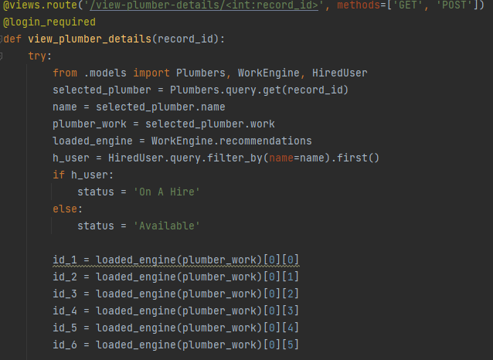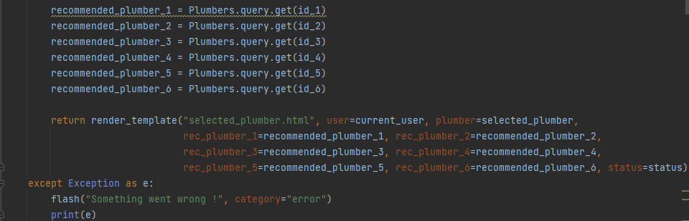

This function is responsible for viewing the details of the selected plumber as well as checking the plumber's availability. This function will also check the work of the selected plumber and pass it to the recommendation function of the work engine class, which was imported from the model file, to find 6 best-matched plumbers who do work that is similar to the work of the selected plumber.

* + - 1. **Output**

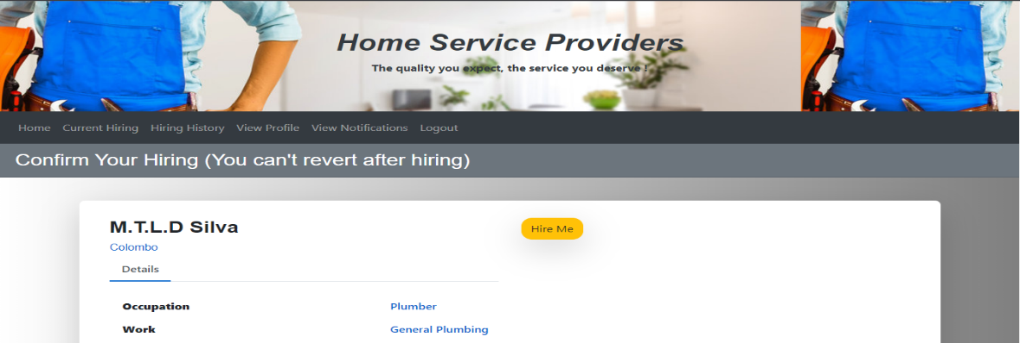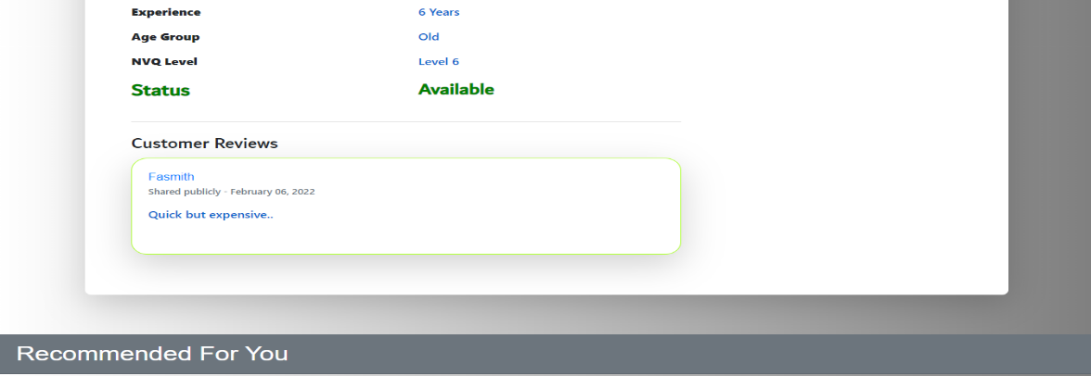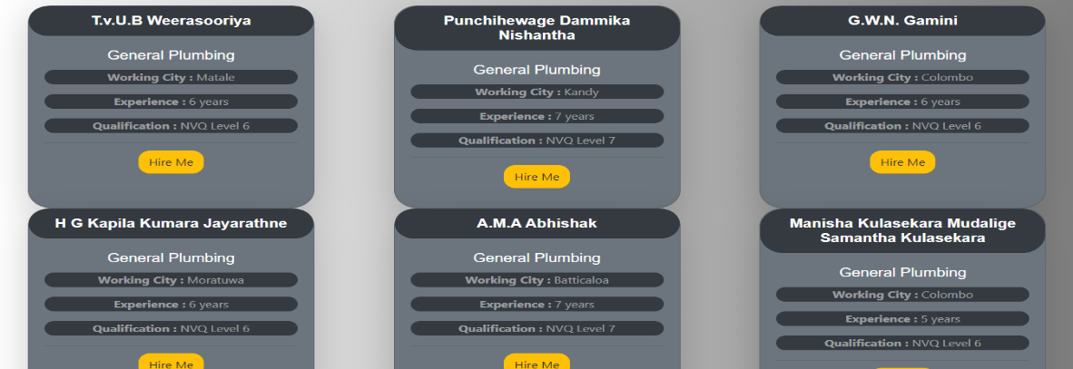

Figure 21: Output of "recommendation based on selected plumber’s work"

* + 1. **Recommendation based on city where user lives.**

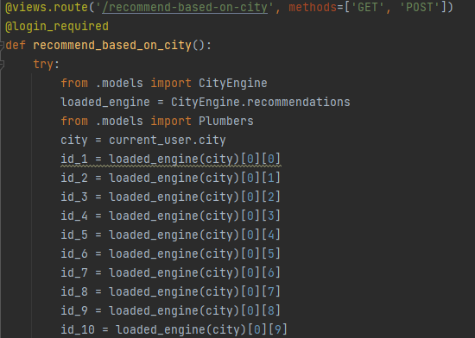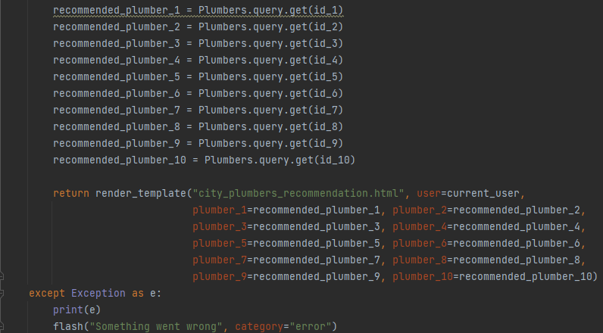

Figure 22: Recommendation based on city where user lives

This function is in control of displaying all of the plumbers in the logged-in user's city. This is accomplished by obtaining the user's city and passing it to the recommendation function of the city engine class, which will be imported from the model file, in terms of finding ten best-matched plumbers who work in the same city as the logged in user.

* + - 1. **Output**

Figure 23: Output of "recommendation based on city where user lives"

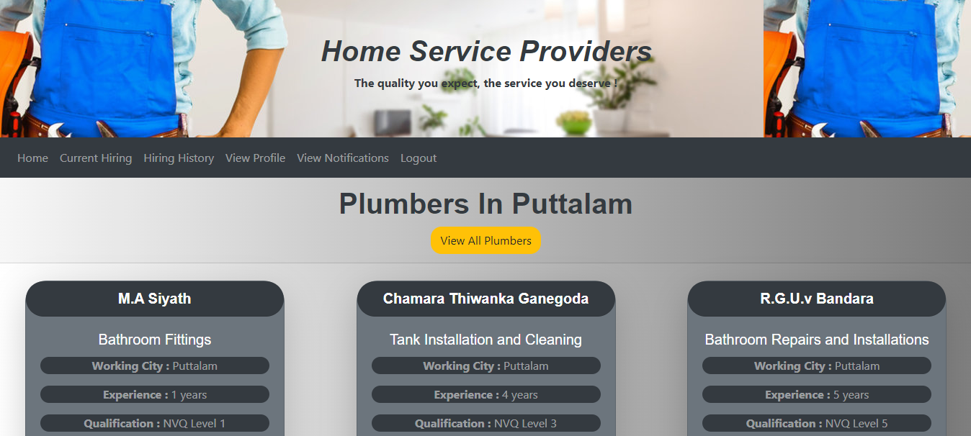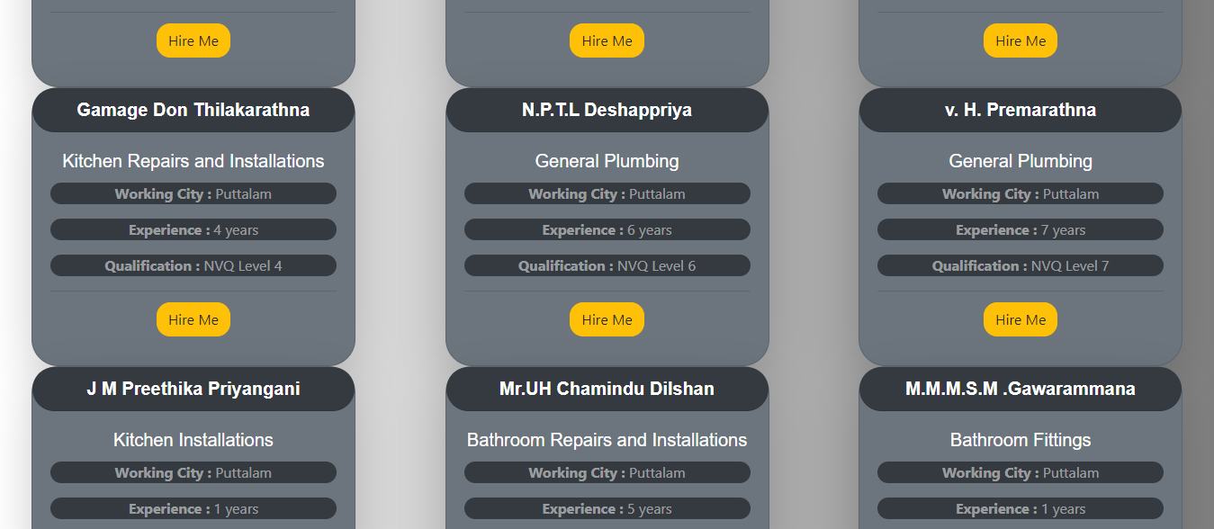

* + 1. **Recommendation based on the user interest**

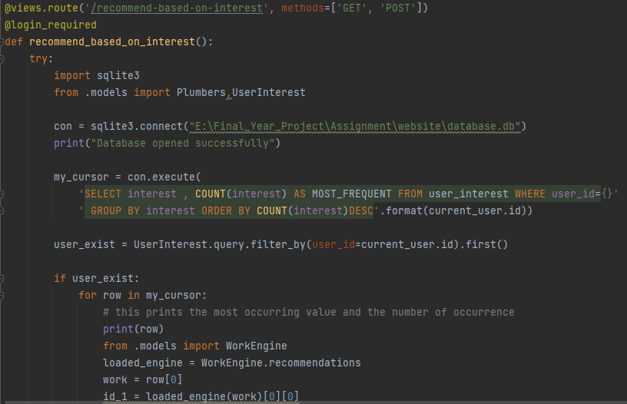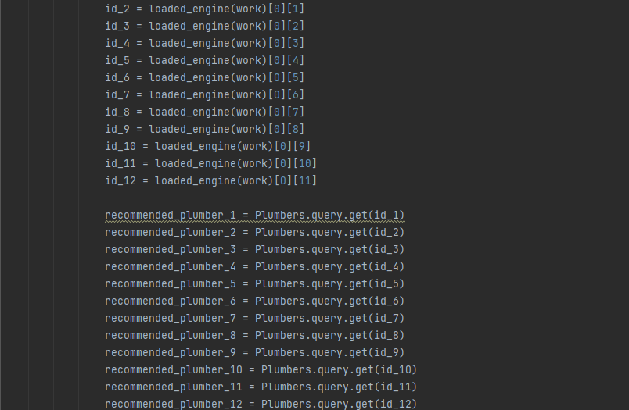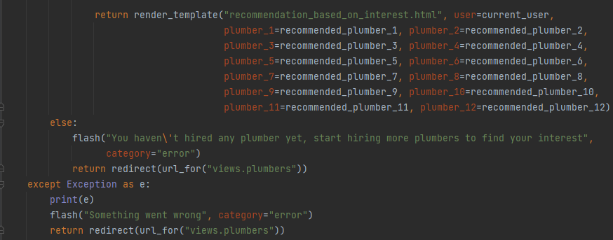

Figure 24: Recommendation based on the user interest

This function will search the user interest table for the most frequently hired plumbering jobs in order to determine which plumbering jobs the currently logged-in user is most interested in hiring. The SQL query will retrieve the logged in user's frequently hired plumbering work and store it in a variable. The recommendation function of the work engine class, which was imported from the model file, will use that variable to find 12 best-matched plumbers who do work that is similar to the work that the currently logged in user is interested in.

* + - 1. **Output**

Figure 25: Output of "recommendation based on the user interest"

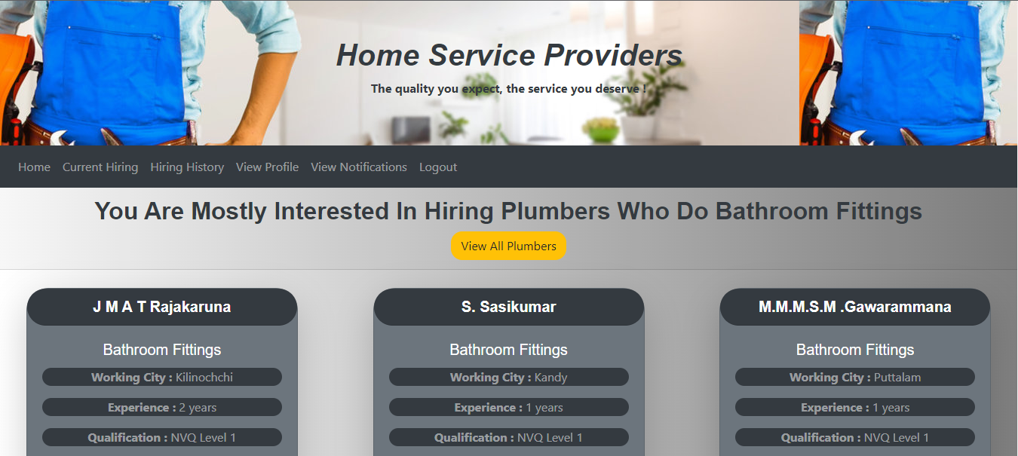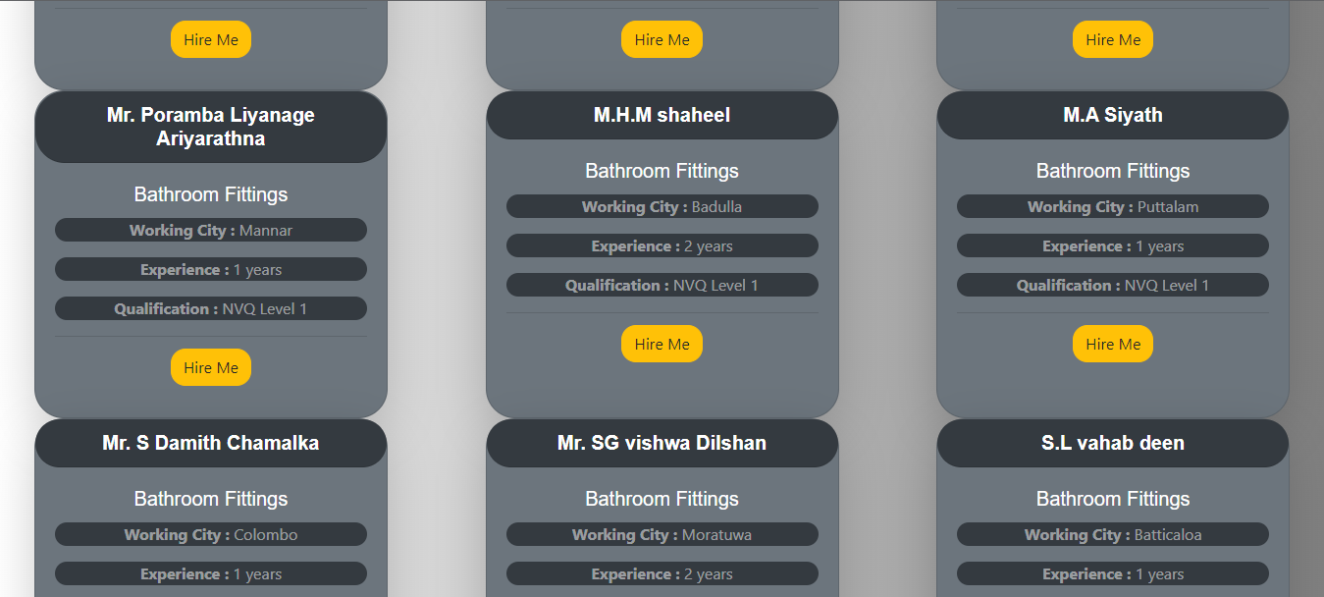

# Testing

## Research on Test Plan

Test scope, test objectives, test strategy, test environment, test deliverables, methods, techniques, and tools to be used are described in a test plan.

* + 1. **Strategies and Techniques**

Software testing is the process of evaluating software with the goal of identifying errors and bugs. Software testing is also used to check the system's reliability, usability, code integrity, security, efficiency, maintainability, and other quality factors. Testing assists the developer in identifying errors and bugs that may have been missed during development and also helps in delivering a high-quality end product to the user (Sawant, et al., 2012).

* + - 1. **Manual Testing**

Manual testing is where testing is done statically. It is carried out in the early stages of the development cycle and is a time-consuming process. In other words, static testing is a type of manual testing that is usually conducted by developers, test teams, and analysts. This testing does not necessitate the execution of the software application's code (Sawant, et al., 2012).

Techniques of manual testing are conducted in 4 ways:

* **Informal Review**:

The document's creator presents the contents to the audience, who then gives their feedback, allowing faults and flaws to be identified early on (GeeksforGeeks, 2019).

* **Walkthrough:**

This method is used by experts to check for defects so that problems do not arise during the development or testing phases (GeeksforGeeks, 2019).

* **Inspection:**

This technique involves verifying documents with a greater authority, such as software requirement specifications (GeeksforGeeks, 2019).

* **Technical Review:**

This technique entails comparing documents in order to identify and correct errors. It is primarily carried out in a group of coworkers (GeeksforGeeks, 2019).

Since the dataset of this application is merged by collecting different information of Sri Lankan plumbers, the quality of the dataset may reduce. Manual testing is carried out to test the final dataset in this application.

* + - 1. **Automated testing**

The purpose of this testing is to look at the code's dynamic behavior. It also involves software testing for the input and output values to be analyzed (GeeksforGeeks, 2019). This is also called as automated testing

There are 4 types of automated testing:

* **Correctness testing**

This way of testing involves the user to run the system to find errors.

* **Reliability testing**

This method of testing aids in the early detection of design flaws and, as a result, provides assurance that the system meets its reliability requirements (Sawant, et al., 2012).

* **Security testing**

This method of testing ensures that only authorized personnel can use the software and access the features that are appropriate for their security level (Sawant, et al., 2012).

* **Performance testing**

This method of testing allows us to measure the performance characteristics of the application (Sawant, et al., 2012).

* + - * 1. **Correctness testing**

This way of testing has 3 techniques:

* White box testing
* Black box testing
* Grey box testing

**White box testing**

White box testing is a powerful tool for detecting and resolving issues. White box testing is the process of providing a system with an input and observing how it processes that input to produce the desired output. This method enables testers to examine and verify a software system's internal workings (Sawant, et al., 2012). This is also considered as functional testing by developers and experts.

* This testing technique mainly focuses on:
* Output that is expected to be returned
* Identify any codes that are broken or badly written.
* Identify the application's security flaws and vulnerabilities.

**Black box testing**

This testing strategy is critical because it will be tested from the perspective of the user without requiring any prior knowledge of the implementation. This is primarily used to ensure that the application as a whole is functioning properly. This ensures that the input is correctly accepted and that the output is properly generated (Sawant, et al., 2012).

## Test Plan

Tests on each of the web application's functions, as well as the core recommendation functions, will be carried out. This will be done using the white and black box testing technique, which involves providing inputs and expecting the application to return an expected output in order to confirm that the app is ready for release. The application's final success percentage is expected to be at least above 90%, which will be calculated based on the number of test cases that passed and the number of test cases that failed the testing.

This application will be subjected to performance testing in order to assess its overall quality. To ensure that the application is release ready, the time it takes to run each function, the time it takes to load each page, the time it takes to get the user's recommendation, and much more will be tested together.

Finally, we'll perform security testing to ensure that the application doesn't crash even if an error occurs, that the customer page and functionalities are only accessible if the user is logged in, and that the customer password is properly encrypted.

## Test Cases

|  |  |  |  |  |  |  |
| --- | --- | --- | --- | --- | --- | --- |
| Test ID | Test Details | Inputs | Event Flow | Expected Results | Actual Results | Status |
| TC001 | Login with existing customer credentials | Email: [shifny@gmail.com](mailto:shifny@gmail.com)  Password:  shifny123 | 1.Open browser  2.Enter url: http://127.0.0.1:5000/  3.Enter email  4.Enter password  5.Click Login | Login and display customer homepage | Logs in the member and displays customer homepage | **PASS** |
| TC002 | Login with existing user email and wrong password | Email: [shifny@gmail.com](mailto:shifny@gmail.com)  Password:  shifny321 | 1.Open browser  2. Enter url: http://127.0.0.1:5000/  3.Enter email  4.Enter password  5.Click Login | Display “Incorrect password, try again!” | Displays “Incorrect password, try again!” | **PASS** |
| TC003 | Login with non-existing user email and password | Email: [jason@gmail.com](mailto:jason@gmail.com)  Password:  jason123 | 1.Open browser  2. Enter url: http://127.0.0.1:5000/  3.Enter email  4.Enter password  5.Click Login | Display “User does not exist.” | Displays “User does not exist.” | **PASS** |
| TC004 | Login with empty values | - | 1.Open browser  2. Enter url: http://127.0.0.1:5000/  3. Click Login | Display “Please fill out this field | Displays “Please fill out this field | **PASS** |
| TC005 | Register user with empty field or fields | - | 1.Open browser  2. Enter url: http://127.0.0.1:5000/  3. Click Sign up in Nav Bar  4. Click Register | Display “Please fill out this field | Displays “Please fill out this field | **PASS** |
| TC006 | Register a user with already existing user’s email | Full name: Peter  Email: [shifny@gmail.com](mailto:shifny@gmail.com)  Password: peter123  City: Puttalam  Address: 24/27, lily avenue | 1.Open browser  2.Enter url: http://127.0.0.1:5000/  3. Click Sign up in Nav Bar  4. Fill Form  5. Click Sign up | Display “Email is already taken, try another email.” | Displays “Email is already taken, try another email.” | **PASS** |
| TC007 | Register a user with full name with characters less than 3 | Full name: Pe  Email: [peter@gmail.com](mailto:peter@gmail.com)  Password: peter123  City: Puttalam  Address: 24/27, lily avenue | 1.Open browser  2.Enter url: http://127.0.0.1:5000/  3. Click Sign up in Nav Bar  4. Fill Form  5. Click Sign up | Display " Full name must be greater than 2 characters" | Displays " Full name must be greater than 2 characters” | **PASS** |
| TC008 | Register a user with Address with characters less than 10 | Full name: Josh  Email: [josh@gmail.com](mailto:josh@gmail.com)  Password: josh1234  City: Puttalam  Address: lily rd. | 1.Open browser  2.Enter url: http://127.0.0.1:5000/  3. Click Sign up in Nav Bar  4. Fill Form  5. Click Sign up | Display " Address is too short!" | Displays " Address is too short” | **PASS** |
| TC009 | Register user with not matching password 1 and password 2 | Full name: Peter  Email: [peter@gmail.com](mailto:peter@gmail.com)  Password: peter123  Confirm Password: peter321  City: Puttalam  Address: 24/27, lily avenue | 1.Open browser  2.Enter url: http://127.0.0.1:5000/  3. Click Sign up in Nav Bar  4. Fill Form  5. Click Sign up | Display “Passwords don't match” | Displays “Passwords don't match” | **PASS** |
| TC010 | Register a user with password less than 7 characters | Full name: Jack  Email: [jack@gmail.com](mailto:jack@gmail.com)  Password:  jack12  City: Puttalam  Address: 24/27, lily avenue | 1.Open browser  2.Enter url: http://127.0.0.1:5000/  3. Click Sign up in Nav Bar  4. Fill Form  5. Click Sign up | Display “Password must be at least 7 characters” | Displays “Password must be at least 7 characters” | **PASS** |
| TC011 | Register a user with email less than 6 characters | Full name: Jack  Email: [j@g.c](mailto:jack@gmail.com)  Password:  jack123  City: Puttalam  Address: 24/27, lily avenue | 1.Open browser  2.Enter url: http://127.0.0.1:5000/  3. Click Sign up in Nav Bar  4. Fill Form  5. Click Sign up | Display “Email must be greater than 5 characters” | Displays “Email must be greater than 5 characters” | **PASS** |
| TC012 | Register with all correct details | Full name: Test Profile  Email: [test1234@gmail.com](mailto:jack@gmail.com)  Password:  test1234  City: Puttalam  Address: 24/27, lily avenue | 1.Open browser  2.Enter url: http://127.0.0.1:5000/  3. Click Sign up in Nav Bar  4. Fill Form  5. Click Sign up | Display “Successfully signed up” and add the user to database with encrypted password | Displays “Successfully signed up” and adds the user to database with encrypted password | **PASS** |
| TC013 | Logout from the application | - | 1. Click Logout in Nav Bar | Log out the user and display “You have been logged out from our application” | Logs out the user and displays “You have been logged out from our application” | **PASS** |
| TC014 | Access customer page without logging-in | - | 1.Open browser  2.Enter url: http://127.0.0.1:5000/current-hiring | Display “Please log in to access this page” | Displays “Please log in to access this page” | **PASS** |
| TC015 | View Plumber’s page | - | 1. Login  2. Click “Hire a Plumber” | Display plumbers page with all the plumbers | Displays plumbers page with all the plumbers | **PASS** |
| TC016 | View plumber detail | - | 1. Login  2. Click “Hire a Plumber”  3. Click “Hire me” | Display selected plumber details and review of the plumber.  Display recommended plumbers. | Displays selected plumber details and review of the plumber.  Displays recommended plumbers. | **PASS** |
| TC017 | Hire a plumber who works in a city where currently logged in user doesn’t live | Logged in user city: Puttalam  Hiring Plumber city: Colombo | 1. Login  2. Click “Hire a Plumber”  3. Click “Hire me”  4. Click “Hire me” | Display “<plumber name> is currently working <plumber city>, you can only hire plumbers from <user city>” | Displays A. Yaparoopan is currently working Colombo, you can only hire plumbers from Puttalam | **PASS** |
| TC018 | Get recommendation based on logged in user’s city | Logged in user city: Puttalam | 1. Login  2. Click “Hire a Plumber”  3. Click “Recommend based on my city” | Display recommended plumbers based on currently logged in user’s city | Displays recommended plumbers based on currently logged in user’s city | **PASS** |
| TC019 | Get recommendation based on logged in user’s interest | Frequently hired work of plumber by logged in user: Bathroom Fittings | 1. Login  2. Click “Hire a Plumber”  3. Click “Recommend based on my interest” | Display recommended plumbers based on currently logged in user’s interest | Displays recommended plumbers based on currently logged in user’s interest | **PASS** |
| TC020 | Getting recommendation based on user interest without having any past hirings | - | 1. Login  2. Click “Hire a Plumber”  3. Click “Recommend based on my interest” | Display “You haven't hired any plumber yet, start hiring more plumbers to find your interest” | Displays “You haven't hired any plumber yet, start hiring more plumbers to find your interest” | **PASS** |
| TC021 | Get recommendation based on user selected plumber’s work | - | 1. Login  2. Click “Hire a Plumber”  3. Click “Hire me” | Display selected plumber details and review of the plumber.  Display recommended plumbers based on the selected plumber’s work. | Displays selected plumber details and review of the plumber.  Displays recommended plumbers based on the selected plumber’s work. | **PASS** |
| TC022 | Hire a plumber who works in the city where currently logged in user lives | Logged in user city: Puttalam | 1. Login  2. Click “Hire a Plumber”  3. Click “Recommend based on my city”  4. Click “Hire me”  5. Click “Hire me” | Display success message and redirect user to current hiring page and display the currently hired plumber  Send a notification to the user | Display “Chamara Thiwanka Ganegoda is hired successfully” and redirect user to current hiring page and display the currently hired plumber  Send a notification to the user | **PASS** |
| TC023 | Hire another plumber while having a plumber already hired | - | 1. Login  2. Click “Hire a Plumber”  3. Click “Hire me”  4. Click “Hire me” | Display error message to the user and redirect the user to current hiring page | Display “A plumber has already been hired by you. Once the current hire is completed, you can hire more” and redirect user to current hiring page. | **PASS** |
| TC024 | Another user trying to hire a plumber who is already on a hire currently | - | 1. Login  2. Click “Hire a Plumber”  3. Click “Hire me”  4. Click “Hire me” | Display error message to the user and redirect the user to plumber’s page | Displays “Chamara Thiwanka Ganegoda is already on hire” and redirect user to plumber page | **PASS** |
| TC025 | Trying to hire the same plumber again who was hired by the current user currently | - | 1. Login  2. Click “Hire a Plumber”  3. Click “Hire me”  4. Click “Hire me” | Display error message to the user and redirect the user to plumber’s page | Displays “Chamara Thiwanka Ganegoda is already on hire” and redirect user to plumber page | **PASS** |
| TC026 | View details of hired plumber | - | 1. Click Current Hiring  2. Click View details | Display hired plumber details and status as “On The Way” | Displays hired plumber details and status as “On The Way” | **PASS** |
| TC027 | Update hired plumber as arrived | - | 1. Click Current Hiring  2. Click Arrived | Update the hired plumber status as “Arrived” and display success message  Send notification to the user. | Update the hired plumber status as “Arrived” and displays “Chamara Thiwanka Ganegoda has arrived at your location” “Make sure to click work completed button once the work is done”  Sends notification to the user. | **PASS** |
| TC028 | View Details of hired plumber after arrival | - | 1. Click Current Hiring  2. Click View details | Display hired plumber details and status as “Arrived” | Displays hired plumber details and status as “Arrived” | **PASS** |
| TC029 | Update hired plumber as work completed | - | 1. Click Current Hiring  2. Click Work Completed | Save the hiring details in hired history database table with status as “Completed” and delete the current hiring of the user.  Redirect user to hired history page and display completed hirings of user and  display success message and send notification to the user. | Saves the hiring details in hired history database table with status as “Completed” and deletes the current hiring of the user.  Display “Chamara Thiwanka Ganegoda has completed his service” “Please pay the service amount requested by the plumber” and send notification to the user. | **PASS** |
| TC030 | View Hiring details of past hired plumber | - | 1. Click Hiring History  2. Click View details | Display details of hiring including date of hiring completion and status | Displays details of hiring including date of hiring completion and status | **PASS** |
| TC031 | Add a review to service which was completed hiring | Review: Great service | 1. Click Hiring History  2. Click View details  3. Enter review  4. Click add review | Add the review to the database with key information such as review, user id, plumber id and the hiring completed date  And display the added review to the user | Adds the review to the database with key information such as review, user id, plumber id and the hiring completed date  And displays the added review to the user | **PASS** |
| TC032 | Add a review with characters less than 5 | Review: gre | 1. Click Hiring History  2. Click View details  3. Enter review  4. Click add review | Display “Please lengthen this text to 5 characters or more” | Displays “Please lengthen this text to 5 characters or more” | **PASS** |
| TC033 | View profile | - | 1. Click View Profile | Display currently logged in user’s profile | Displays currently logged in user’s profile | **PASS** |
| TC034 | Get recommendation based on user interest while having only hired 1 plumbering service | - | 1. Login  2. Click “Hire a Plumber”  3. Click “Recommend based on my interest” | Display recommended plumbers based on currently logged in user’s only hired plumber’s work | Displays recommended plumbers based on currently logged in user’s only hired plumber’s work | **PASS** |
| TC035 | Get recommendation based on user interest while having only hired 2 plumbering service | - | 1. Login  2. Click “Hire a Plumber”  3. Click “Recommend based on my interest” | Display recommended plumbers based on currently logged in user’s last hired plumber’s work | Displays recommended plumbers based on currently logged in user’s last hired plumber’s work | **PASS** |
| TC036 | Get recommendation based on user interest while having hired 3 or more plumbering service but each of the plumbering service are unique and doesn’t repeat(no frequent hirings) | - | 1. Login  2. Click “Hire a Plumber”  3. Click “Recommend based on my interest” | Display recommended plumbers based on currently logged in user’s last hired plumber’s work | Displays recommended plumbers based on currently logged in user’s last hired plumber’s work | **PASS** |
| TC037 | View Edit Profile page | - | 1. Click View Profile  2. Click Edit Profile | Display “edit profile” page with user details in editable fields. | Displays “edit profile” page with user details in editable fields. | **PASS** |
| TC038 | Edit Profile with existing user’s email which is not currently logged in user’s email | Email: shifny@gmail.com | 1. Click View Profile  2. Click Edit Profile  3. Update details/detail  4. Click update profile | Display “Email is already taken, try another email.” | Displays “Email is already taken, try another email.” | **PASS** |
| TC039 | Edit Profile with full name less than 3 characters | Full name: JD | 1. Click View Profile  2. Click Edit Profile  3. Update details/detail  4. Click update profile | Display " Full name must be greater than 2 characters" | Displays “Full name must be greater than 2 characters” | **PASS** |
| TC040 |  |  |  | Display “Address is too short!” | Displays “Address is too short” | **PASS** |

# Critical Evaluation

# Conclusion

# Reference

Alpaydin, E., 2020. *Introduction to Machine Learning.* 4th ed. Cambridge: Massachisetts Institute of Technology.

Amaratunga, D., Fernando, N., Haigh, R. & Jayasinghe, N., 2020. Progress in Disaster. *The COVID-19 outbreak in Sri Lanka: A synoptic analysis focusing on trends, impacts, risks and science-policy interaction processes,* 8(100133).

Amaratunga, D., Fernando, N., Haigh, R. & Jayasinghe, N., 2020. Progress in Disaster Science. *The COVID-19 outbreak in Sri Lanka: A synoptic analysis focusing on trends, impacts, risks and science-policy interaction processes,* 8(100133).

Chung, L., Brian, N. A., Yu, E. & Mylopoulos, J., 2000. *Non-Functional Requirenments in Software Engineering.* 1st ed. New York: Kluwer Academic Publishers.

De Silva, N. & Ranasinghe, M., 2010. Maintainability risks of condominiums in Sri Lanka. *Journal of Financial Management of Property and Construction,* 15(1), pp. 41-60.

Ekstrand, D. M., Riedl, T. J. & Konstan, A. J., 2010. *Collaborative filtering recommender systems.* 2nd ed. Netherland: Foundation and Trends.

Garcia, R. et al., 2020. A systematic literature review on the use of machine learning in precision livestock farming. *Computers and Electronics in Agriculture,* 179(105829).

Geeksforgeeks, 2020. *Using CountVectorizer to Extracting Features from Text.* [Online]   
Available at: https://www.geeksforgeeks.org/using-countvectorizer-to-extracting-features-from-text/  
[Accessed 23 12 2021].

International Labour Organization, 2020. *Working from Home: Estimating the worldwide potential,* Switzerland: International Labour Organization.

Meteren, R. v. & Someren, M. v., 2000. *Using Content-Based Filtering for Recommendation,* Netherlands: NetlinQ Group.

Paireekreng, W., 2013. *Mobile content recommendation system for re-visiting user using content-based filtering and client-side user profile,* Tianjin: IEEE.

Ribeiro, M., Grolinger, K. & Capretz, A. M., 2015. *MLaaS: Machine Learning as a Service,* Miami: IEEE.

Ryngksai, I. & Chameikho, L., 2014. ecommender Systems: Types of Filtering. *International Journal of Engineering Research & Technology,* 3(11), pp. 251-254.

Salton, G. & Buckley, C., 1988. Term-Weighting Approaches in Automatic Text Retrieval. *Information Processing & Management,* 5(24), pp. 513-523.

Shoval, P., Maidel, V. & Shapira, B., 2008. An Ontology- Content-based Filtering Method. *Information Theories & Applications,* 15(4), pp. 303-314.

Wagner, M., Balke, W. T., Hirschfeld, R. & Kellerer, W., 2002. *A Roadmap to Advanced Personalization of Mobile Services,* Augsberg: ODBASE.

Xu, G., Zhang, Y. & Li, L., 2010. *Web Mining and Social Networking.* 1st ed. New York: Springer.

Ye, J., 2011. Cosine similarity measures for intuitionistic fuzzy sets and their applications. *Mathematical and Computer Modelling,* 53(2), pp. 91-97.

# Appendix

## Project Planning

|  |  |  |  |  |  |  |  |  |  |  |  |  |  |  |  |  |  |  |  |  |  |  |  |  |  |  |  |
| --- | --- | --- | --- | --- | --- | --- | --- | --- | --- | --- | --- | --- | --- | --- | --- | --- | --- | --- | --- | --- | --- | --- | --- | --- | --- | --- | --- |
| ID | Tasks | Duration | Aug | | | | Sep | | | | Oct | | | | Nov | | | | Dec | | | | Jan and Feb | | | | |
| 1 | PPF | 5days |  |  |  |  |  |  |  |  |  |  |  |  |  |  |  |  |  |  |  |  |  |  |  |  |
| 2 | PSR | 3weeks |  |  |  |  |  |  |  |  |  |  |  |  |  |  |  |  |  |  |  |  |  |  |  |  |
| 3 | Project Research | 5Weeks |  |  |  |  |  |  |  |  |  |  |  |  |  |  |  |  |  |  |  |  |  |  |  |  |
| 4 | MPR | 2Weeks |  |  |  |  |  |  |  |  |  |  |  |  |  |  |  |  |  |  |  |  |  |  |  |  |
| 5 | Additional Research | 5Weeks |  |  |  |  |  |  |  |  |  |  |  |  |  |  |  |  |  |  |  |  |  |  |  |  |
| 6 | Developing Frontend Prototype | 3Week |  |  |  |  |  |  |  |  |  |  |  |  |  |  |  |  |  |  |  |  |  |  |  |  |
| 7 | Prototype Testing | 5days |  |  |  |  |  |  |  |  |  |  |  |  |  |  |  |  |  |  |  |  |  |  |  |  |
| 8 | Developing Frontend | 5Weeks |  |  |  |  |  |  |  |  |  |  |  |  |  |  |  |  |  |  |  |  |  |  |  |  |
| 9 | Developing Backend | 8Weeks |  |  |  |  |  |  |  |  |  |  |  |  |  |  |  |  |  |  |  |  |  |  |  |  |
| 10 | Connect Frontend and Backend | 3Weeks |  |  |  |  |  |  |  |  |  |  |  |  |  |  |  |  |  |  |  |  |  |  |  |  |
| 11 | Complete Documentation | 2Weeks |  |  |  |  |  |  |  |  |  |  |  |  |  |  |  |  |  |  |  |  |  |  |  |  |
| 12 | System Testing | 2Week |  |  |  |  |  |  |  |  |  |  |  |  |  |  |  |  |  |  |  |  |  |  |  |  |
| 13 | Complete the project | 3Weeks |  |  |  |  |  |  |  |  |  |  |  |  |  |  |  |  |  |  |  |  |  |  |  |  |
| 14 | Final Submission Checking | 3Weeks |  |  |  |  |  |  |  |  |  |  |  |  |  |  |  |  |  |  |  |  |  |  |  |  |